# Analysis of CNN Architecture in the Code

Yes, the code follows the standard CNN architecture flow I described earlier. Let me break down how each component is implemented:

## 1. Input Layer
```python
# In the load_data function:
X = X.reshape(X.shape[0], 1, X.shape[2]) # Reshapes to (samples, channels, features)
```
- The input data is reshaped to have 1 channel with 5 features (as shown in the output: "Data loaded: 1073623 samples, 5 features, 6 classes")

## 2. Convolutional Layers
```python
# In ActivityCNN class:
self.conv1 = nn.Conv1d(1, 32, kernel_size=3, stride=1, padding=1)
self.conv2 = nn.Conv1d(32, 64, kernel_size=3, stride=1, padding=1)
```
- First conv layer: 1 input channel → 32 output channels
- Second conv layer: 32 input channels → 64 output channels
- Both use 3×1 kernels with padding to maintain spatial dimensions

## 3. Activation Functions
```python
# In forward method:
x = F.relu(self.conv1(x))
x = F.relu(self.conv2(x))
x = F.relu(self.fc1(x))
```
- ReLU activation is applied after each convolutional and fully connected layer (except the output layer)

## 4. Pooling Layers
```python
# In forward method:
x = F.max_pool1d(x, 2) # After first conv
x = F.max_pool1d(x, 2) # After second conv
```
- Max pooling with kernel size 2 is applied after each convolutional layer
- This reduces the spatial dimensions by half each time

## 5. Fully-Connected Layers
```python
# In ActivityCNN class:
self.fc1 = nn.Linear(64 * self.feature_size, 128)
self.fc2 = nn.Linear(128, num_classes)
```
- First FC layer: Flattened features → 128 neurons
- Second FC layer: 128 neurons → output classes (6 in this case)
- Includes dropout for regularization: `self.dropout = nn.Dropout(0.5)`

## 6. Output Layer
```python
# The output from self.fc2 produces logits for 6 classes
# In train_model and evaluate_model functions:
_, predicted = torch.max(outputs, 1) # Gets the class with highest probability
```
- The model outputs logits for 6 activity classes
- CrossEntropyLoss is used which implicitly applies softmax: `criterion = nn.CrossEntropyLoss()`

## Complete Data Flow
The forward method shows the full flow:
```python
def forward(self, x):
# First convolutional block
x = F.relu(self.conv1(x))
x = F.max_pool1d(x, 2)

# Second convolutional block
x = F.relu(self.conv2(x))
x = F.max_pool1d(x, 2)

# Flatten
x = x.view(x.size(0), -1)

# Fully connected layers
x = F.relu(self.fc1(x))
x = self.dropout(x)
x = self.fc2(x)

return x
```

This is a 1D CNN for time series data (human activity recognition), but it follows the same architectural principles as the standard CNN flow I described earlier.

import torch
import torch.nn as nn
import torch.nn.functional as F
from torch.utils.data import Dataset, DataLoader, random_split
import numpy as np
import pandas as pd
import matplotlib.pyplot as plt
from sklearn.metrics import confusion_matrix, classification_report
import seaborn as sns

# Set device
device = torch.device("cuda" if torch.cuda.is_available() else "cpu")
print(f"Using device: {device}")

# 1. Dataset Class
class ActivityDataset(Dataset):
def __init__(self, features, labels):
self.features = torch.tensor(features, dtype=torch.float32).to(device)
self.labels = torch.tensor(labels, dtype=torch.long).to(device)

def __len__(self):
return len(self.features)

def __getitem__(self, idx):
return self.features[idx], self.labels[idx]
- Imports:
  - PyTorch libraries for deep learning
  - Data handling libraries (NumPy, Pandas)
  - Visualization tools (Matplotlib, Seaborn)
  - Evaluation metrics from scikit-learn
- Device Configuration:
  - Sets up PyTorch to use GPU if available, otherwise CPU
  - Prints which device is being used
- Custom Dataset Class:
  - ActivityDataset extends PyTorch's Dataset class
  - Takes features and labels as input
  - Converts them to PyTorch tensors and moves them to the selected device (CPU/GPU)
  - Implements required methods:
    - __len__: Returns the dataset size
    - __getitem__: Returns a specific (feature, label) pair

# 2. CNN Model
class ActivityCNN(nn.Module):
def __init__(self, input_size, num_classes):
super(ActivityCNN, self).__init__()

# Convolutional layers
self.conv1 = nn.Conv1d(1, 32, kernel_size=3, stride=1, padding=1)
self.conv2 = nn.Conv1d(32, 64, kernel_size=3, stride=1, padding=1)

# Calculate output size after convolutions and pooling
self.feature_size = input_size // 4 # After 2 pooling layers (2^2 = 4)

# Fully connected layers
self.fc1 = nn.Linear(64 * self.feature_size, 128)
self.fc2 = nn.Linear(128, num_classes)

# Dropout for regularization
self.dropout = nn.Dropout(0.5)

def forward(self, x):
# First convolutional block
x = F.relu(self.conv1(x))
x = F.max_pool1d(x, 2)

# Second convolutional block
x = F.relu(self.conv2(x))
x = F.max_pool1d(x, 2)

# Flatten
x = x.view(x.size(0), -1)

# Fully connected layers
x = F.relu(self.fc1(x))
x = self.dropout(x)
x = self.fc2(x)

return x

# 3. Load and preprocess data
def load_data(file_path):
print("Loading data...")
df = pd.read_csv(file_path)

# Extract labels (assuming 'activity' column exists)
if 'activity' in df.columns:
y = df.pop('activity').values
elif 'Activity' in df.columns:
y = df.pop('Activity').values
else:
# Find activity column
label_col = [col for col in df.columns if 'activity' in col.lower() or 'label' in col.lower()]
if label_col:
y = df.pop(label_col[0]).values
else:
raise ValueError("Could not find activity label column")

# Convert string labels to integers if needed
if isinstance(y[0], str):
unique_labels = sorted(set(y))
label_to_idx = {label: idx for idx, label in enumerate(unique_labels)}
y = np.array([label_to_idx[label] for label in y])
class_names = unique_labels
else:
class_names = [str(i) for i in range(len(set(y)))]

# Features are all remaining columns
X = df.values

# Normalize features
X = (X - X.mean(axis=0)) / (X.std(axis=0) + 1e-8)

# Reshape for 1D CNN: (samples, channels, features)
X = X.reshape(X.shape[0], 1, X.shape[1])

print(f"Data loaded: {X.shape[0]} samples, {X.shape[2]} features, {len(class_names)} classes")
return X, y, class_names

# 4. Train function
def train_model(model, train_loader, val_loader, criterion, optimizer, epochs=10):
train_losses = []
val_losses = []

for epoch in range(epochs):
# Training
model.train()
running_loss = 0.0
correct = 0
total = 0

for inputs, labels in train_loader:
optimizer.zero_grad()
outputs = model(inputs)
loss = criterion(outputs, labels)
loss.backward()
optimizer.step()

running_loss += loss.item() * inputs.size(0)
_, predicted = torch.max(outputs, 1)
total += labels.size(0)
correct += (predicted == labels).sum().item()

train_loss = running_loss / len(train_loader.dataset)
train_acc = correct / total
train_losses.append(train_loss)

# Validation
model.eval()
running_loss = 0.0
correct = 0
total = 0

with torch.no_grad():
for inputs, labels in val_loader:
outputs = model(inputs)
loss = criterion(outputs, labels)

running_loss += loss.item() * inputs.size(0)
_, predicted = torch.max(outputs, 1)
total += labels.size(0)
correct += (predicted == labels).sum().item()

val_loss = running_loss / len(val_loader.dataset)
val_acc = correct / total
val_losses.append(val_loss)

print(f"Epoch {epoch+1}/{epochs} - "
f"Train loss: {train_loss:.4f}, Train acc: {train_acc:.4f} - "
f"Val loss: {val_loss:.4f}, Val acc: {val_acc:.4f}")

return train_losses, val_losses

# 5. Evaluate function
def evaluate_model(model, test_loader, class_names):
model.eval()
all_preds = []
all_labels = []

with torch.no_grad():
for inputs, labels in test_loader:
outputs = model(inputs)
_, predicted = torch.max(outputs, 1)

all_preds.extend(predicted.cpu().numpy())
all_labels.extend(labels.cpu().numpy())

# Calculate accuracy
accuracy = sum(np.array(all_preds) == np.array(all_labels)) / len(all_labels)

# Create confusion matrix
cm = confusion_matrix(all_labels, all_preds)

# Print results
print(f"Test Accuracy: {accuracy:.4f}")
print("\nClassification Report:")
print(classification_report(all_labels, all_preds, target_names=class_names))

# Plot confusion matrix
plt.figure(figsize=(10, 8))
sns.heatmap(cm, annot=True, fmt='d', cmap='Blues',
xticklabels=class_names, yticklabels=class_names)
plt.xlabel('Predicted')
plt.ylabel('True')
plt.title('Confusion Matrix')
plt.show()

return accuracy, cm

# 6. Main function
def main():
# Set random seed for reproducibility
torch.manual_seed(42)
np.random.seed(42)

# Parameters
data_path = "path/to/your/activity_data.csv" # Replace with your dataset path
batch_size = 64
learning_rate = 0.001
epochs = 10

# Load data
X, y, class_names = load_data(data_path)
num_classes = len(set(y))
input_size = X.shape[2] # Number of features

# Create dataset
dataset = ActivityDataset(X, y)

# Split data (70% train, 15% validation, 15% test)
total_size = len(dataset)
train_size = int(0.7 * total_size)
val_size = int(0.15 * total_size)
test_size = total_size - train_size - val_size

train_dataset, val_dataset, test_dataset = random_split(
dataset, [train_size, val_size, test_size],
generator=torch.Generator().manual_seed(42)
)

# Create data loaders
train_loader = DataLoader(train_dataset, batch_size=batch_size, shuffle=True)
val_loader = DataLoader(val_dataset, batch_size=batch_size)
test_loader = DataLoader(test_dataset, batch_size=batch_size)

# Initialize model, loss, and optimizer
model = ActivityCNN(input_size, num_classes).to(device)
criterion = nn.CrossEntropyLoss()
optimizer = torch.optim.Adam(model.parameters(), lr=learning_rate)

# Train model
print("Training model...")
train_losses, val_losses = train_model(
model, train_loader, val_loader, criterion, optimizer, epochs=epochs
)

# Plot training curves
plt.figure(figsize=(10, 5))
plt.plot(train_losses, label='Train Loss')
plt.plot(val_losses, label='Validation Loss')
plt.xlabel('Epoch')
plt.ylabel('Loss')
plt.legend()
plt.title('Training and Validation Loss')
plt.show()

# Evaluate model
print("\nEvaluating model on test data...")
accuracy, confusion_matrix = evaluate_model(model, test_loader, class_names)

# Save model
torch.save(model.state_dict(), 'activity_recognition_model.pth')
print("Model saved to activity_recognition_model.pth")

if __name__ == "__main__":
main()

# Understanding CNN Key Concepts

The text describes three fundamental principles that make Convolutional Neural Networks (CNNs) powerful:

## 1. Sparse Interactions
- **Traditional neural networks**: Each output unit connects to every input unit
- **CNNs**: Each output connects to only a small local region of input (the kernel size)
- **Benefit**: Dramatically reduces parameters and improves computational efficiency

## 2. Parameter Sharing
- Same filter/kernel is applied across the entire input
- **Example**: The same edge detector can be used throughout an image
- **Benefit**: Further reduces parameters while allowing the network to learn patterns regardless of position

## 3. Equivariant Representations
- If the input changes (e.g., shifts), the output changes in a predictable way
- **Example**: If an object in an image moves, its features in the representation move correspondingly
- **Benefit**: Helps CNNs recognize patterns regardless of their exact position

## CNN Architecture Flow
```
Input → Convolution Layers → Pooling Layers → Fully-Connected Layers → Output
```

The final fully-connected layers take the features extracted by the convolutional and pooling layers to perform the actual classification or regression task.

# Understanding CNN Architecture Flow

The CNN architecture follows a logical progression designed to extract and process features from input data:

## 1. Input Layer
- **Raw data entry point**: Images (RGB or grayscale), sensor data, etc.
- **Dimensions**: Height × Width × Channels (e.g., 224×224×3 for RGB images)
- **Purpose**: Standardized representation of input data

## 2. Convolutional Layers
- **Operation**: Slide filters/kernels across input to create feature maps
- **Function**: Extract local patterns (edges, textures, shapes)
- **Key parameters**:
- Filter size (e.g., 3×3, 5×5)
- Number of filters (determines feature map depth)
- Stride (step size when sliding filters)
- Padding (preserves spatial dimensions)

## 3. Activation Function
- **Typically ReLU**: Introduces non-linearity
- **Purpose**: Allows network to learn complex patterns
- **Position**: Applied after each convolution

## 4. Pooling Layers
- **Operation**: Downsampling (typically max or average pooling)
- **Purpose**:
- Reduces spatial dimensions
- Provides some translation invariance
- Reduces computation and parameters
- **Common size**: 2×2 with stride 2 (reduces dimensions by half)

## 5. Fully-Connected (Dense) Layers
- **Structure**: Traditional neural network layers
- **Purpose**:
- Interpret features extracted by previous layers
- Perform final classification/regression
- **Operation**: Connect every neuron to all neurons in previous layer

## 6. Output Layer
- **Structure**: Depends on task
- Classification: Neurons equal to number of classes (with softmax)
- Regression: Single or multiple neurons (often linear activation)

## Data Flow Example
```
Input image (224×224×3) →
Conv (64 filters) → ReLU → Pool →
Conv (128 filters) → ReLU → Pool →
Flatten →
Dense (512 neurons) → ReLU →
Dense (output classes) → Softmax
```

This progressive architecture allows CNNs to transform raw input data into increasingly abstract feature representations before making final predictions.

# Input Adaptation Approaches for CNNs

The code you shared doesn't explicitly implement input adaptation techniques, but these could be added to enhance performance. Let me explain both approaches:

## Data-Driven Adaptation

### What It Is
Modifying the input data based on its characteristics without changing the model architecture.

### How to Implement in Your Code

1. **Data Augmentation**:
```python
def augment_time_series(X, y):
augmented_X = []
augmented_y = []

for i in range(len(X)):
# Original sample
augmented_X.append(X[i])
augmented_y.append(y[i])

# Add noise
noise = np.random.normal(0, 0.05, X[i].shape)
augmented_X.append(X[i] + noise)
augmented_y.append(y[i])

# Time warping (simple version)
if X[i].shape[1] > 2:
warped = np.copy(X[i])
warp_factor = np.random.uniform(0.8, 1.2)
# Apply warping to middle section
mid = warped.shape[1] // 2
warped[:, mid:] = np.interp(
np.linspace(0, 1, warped.shape[1] - mid),
np.linspace(0, 1, warped.shape[1] - mid) * warp_factor,
warped[:, mid:]
)
augmented_X.append(warped)
augmented_y.append(y[i])

return np.array(augmented_X), np.array(augmented_y)
```

2. **Feature Engineering**:
```python
def enhance_features(X):
# Original shape: (samples, 1, features)
enhanced_X = np.zeros((X.shape[0], 1, X.shape[2] * 2))

for i in range(X.shape[0]):
# Original features
enhanced_X[i, 0, :X.shape[2]] = X[i, 0, :]

# Add derived features (e.g., rolling statistics)
if i >= 10: # Need enough samples for window
window = X[i-10:i, 0, :]
# Add rolling mean
enhanced_X[i, 0, X.shape[2]:] = np.mean(window, axis=0)

return enhanced_X

# Use in load_data function:
X = enhance_features(X)
```

3. **Adaptive Preprocessing**:
```python
def adaptive_preprocessing(X, y):
# Group by activity
activities = np.unique(y)
processed_X = np.copy(X)

for activity in activities:
# Get indices for this activity
indices = np.where(y == activity)[0]
activity_data = X[indices]

# Activity-specific normalization
mean = np.mean(activity_data, axis=0)
std = np.std(activity_data, axis=0)
processed_X[indices] = (activity_data - mean) / (std + 1e-8)

return processed_X
```

## Model-Driven Adaptation

### What It Is
Modifying the model architecture to better handle the specific input characteristics.

### How to Implement in Your Code

1. **Adaptive Convolutional Layers**:
```python
class AdaptiveActivityCNN(nn.Module):
def __init__(self, input_size, num_classes):
super(AdaptiveActivityCNN, self).__init__()

# Activity-specific feature extractors
self.conv1_walking = nn.Conv1d(1, 16, kernel_size=3, padding=1)
self.conv1_sitting = nn.Conv1d(1, 16, kernel_size=5, padding=2) # Wider kernel

# Shared layers
self.conv2 = nn.Conv1d(32, 64, kernel_size=3, padding=1)
self.feature_size = input_size // 4
self.fc1 = nn.Linear(64 * self.feature_size, 128)
self.fc2 = nn.Linear(128, num_classes)
self.dropout = nn.Dropout(0.5)

def forward(self, x):
# Parallel feature extraction
x1 = F.relu(self.conv1_walking(x))
x2 = F.relu(self.conv1_sitting(x))

# Concatenate features
x = torch.cat([x1, x2], dim=1)

# Continue with shared layers
x = F.max_pool1d(x, 2)
x = F.relu(self.conv2(x))
x = F.max_pool1d(x, 2)

x = x.view(x.size(0), -1)
x = F.relu(self.fc1(x))
x = self.dropout(x)
x = self.fc2(x)

return x
```

2. **Attention Mechanism**:
```python
class AttentionLayer(nn.Module):
def __init__(self, in_features):
super(AttentionLayer, self).__init__()
self.query = nn.Conv1d(in_features, in_features, kernel_size=1)
self.key = nn.Conv1d(in_features, in_features, kernel_size=1)
self.value = nn.Conv1d(in_features, in_features, kernel_size=1)

def forward(self, x):
q = self.query(x)
k = self.key(x)
v = self.value(x)

# Compute attention scores
scores = torch.bmm(q.transpose(1, 2), k) / np.sqrt(k.size(1))
attention = F.softmax(scores, dim=-1)

# Apply attention
out = torch.bmm(v, attention.transpose(1, 2))
return out

# Add to your CNN:
self.attention = AttentionLayer(32) # After first conv layer
```

3. **Dynamic Kernel Selection**:
```python
class DynamicKernelCNN(nn.Module):
def __init__(self, input_size, num_classes):
super(DynamicKernelCNN, self).__init__()

# Multiple kernel sizes
self.conv1_k3 = nn.Conv1d(1, 16, kernel_size=3, padding=1)
self.conv1_k5 = nn.Conv1d(1, 16, kernel_size=5, padding=2)
self.conv1_k7 = nn.Conv1d(1, 16, kernel_size=7, padding=3)

# Kernel selector (learns which kernel to use)
self.kernel_selector = nn.Sequential(
nn.AdaptiveAvgPool1d(1),
nn.Flatten(),
nn.Linear(1, 3),
nn.Softmax(dim=1)
)

# Rest of the network
self.conv2 = nn.Conv1d(16, 64, kernel_size=3, padding=1)
self.feature_size = input_size // 4
self.fc1 = nn.Linear(64 * self.feature_size, 128)
self.fc2 = nn.Linear(128, num_classes)
self.dropout = nn.Dropout(0.5)

def forward(self, x):
# Compute kernel weights
weights = self.kernel_selector(x)

# Apply different kernels
x1 = F.relu(self.conv1_k3(x))
x2 = F.relu(self.conv1_k5(x))
x3 = F.relu(self.conv1_k7(x))

# Weight the outputs
x = weights[:, 0:1].view(-1, 1, 1) * x1 + \
weights[:, 1:2].view(-1, 1, 1) * x2 + \
weights[:, 2:3].view(-1, 1, 1) * x3

# Continue with the rest of the network
x = F.max_pool1d(x, 2)
x = F.relu(self.conv2(x))
x = F.max_pool1d(x, 2)

x = x.view(x.size(0), -1)
x = F.relu(self.fc1(x))
x = self.dropout(x)
x = self.fc2(x)

return x
```

## Implementation Strategy

To implement these adaptations:

1. For data-driven approaches:
- Add them in the `load_data` function before creating the dataset
- Example: `X = enhance_features(X)` or `X, y = augment_time_series(X, y)`

2. For model-driven approaches:
- Replace the `ActivityCNN` class with your enhanced model
- Update the model instantiation in the `main` function

These techniques can significantly improve performance, especially for challenging classes like "Downstairs" and "Upstairs" which show lower precision and recall in your current results.

The reason is that CNN is able to capture the spatial relationship, while RNN can make use of the temporal relationship. Combining CNN and RNN could enhance the ability to recognize different activities that have varied time span and signal distributions.

The movement, behavior, environment, emotion, and thought are critical parts in recognizing high-level activities. However, most work only focused on body movements in smart homes [15], [61], which is not enough to recognize high-level activities. For instance, [61] combined activity and environment signal to recognize activities in a smart home, but the activities are constrained to body movements without more information on user emotion and state, which are also important. In the future, we expect there will be more research in this area.

Therefore, it is suggested to use body-worn sensors (mostly accelerometer+gyroscope) for ADL and sports activities. If the activities are pertaining to some semantic meaning but more than simple body movements, it is better to combine the object and ambient sensors.

RNN and LSTM are recommended to recognize short activities that have natural order while CNN is better at inferring long-term repetitive activities [21]. The reason is that RNN could make use of the time-order relationship between sensor readings, and CNN is more capable of learning deep features contained in recursive patterns. For multi-modal signals, it is better to use CNN since the features can be integrated through multi-channel convolutions [19], [70], [76]. While adapting CNN, data-driven approaches are better than model-driven approaches as the inner properties of the activity signal can be exploited better when the input data are transformed into the virtual image. Multiple convolutions and poolings also help CNN perform better. RBM and autoencoders are usually pre-trained before being fine-tuned. Multi-layer RBM or SAE is preferred for more accurate recognition.

For a single model, CNN with shifted inputs (Fourier transform) generates better results compared to shifted kernels.

  - Result Analysis of CNN
- Training and Validation Loss
The model was trained over 10 epochs, with the loss curves indicating the learning efficiency of the CNN. As depicted in Figure *, both training and validation losses decreased consistently and showed a clear trend of convergence, indicating effective learning and minimal overfitting.

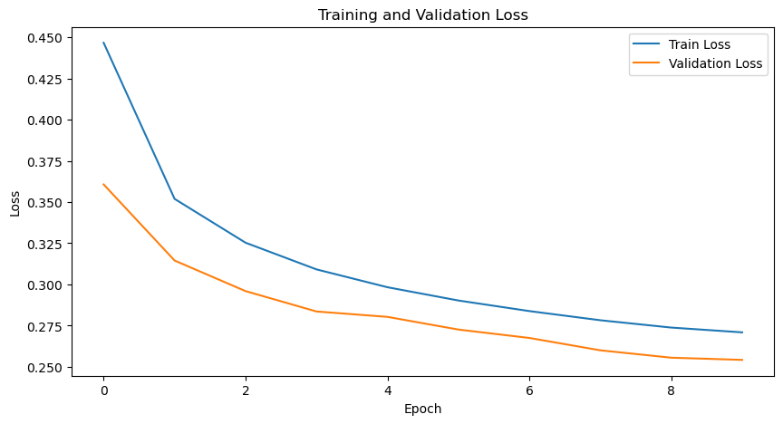
Figure *: Training and Validation Loss Curves
- Accuracy Evaluation
Upon testing, the model achieved a test accuracy of 89.06%, validating its effectiveness in generalizing to new data. The model's accuracy improved steadily throughout the training process, achieving high accuracy rates by the final epoch. The accuracy metrics demonstrate the model's robust learning capability, with a close alignment between training and validation accuracies.
Table *: Accuracy Increasement of Epochs
Epoch | Training Accuracy (%) | Validation Accuracy (%)
1 | 80.51% | 84.48%
5 | 87.24% | 88.00%
10 | 88.55% | 89.07%
- Confusion Matrix Analysis
The confusion matrix shown as Figure* provides an in-depth view of the model's classification performance across different activities. The matrix reveals high accuracy in classifying activities, with most predictions correctly aligned along the diagonal. Misclassifications were noted between activities with similar movement patterns, such as walking and jogging.

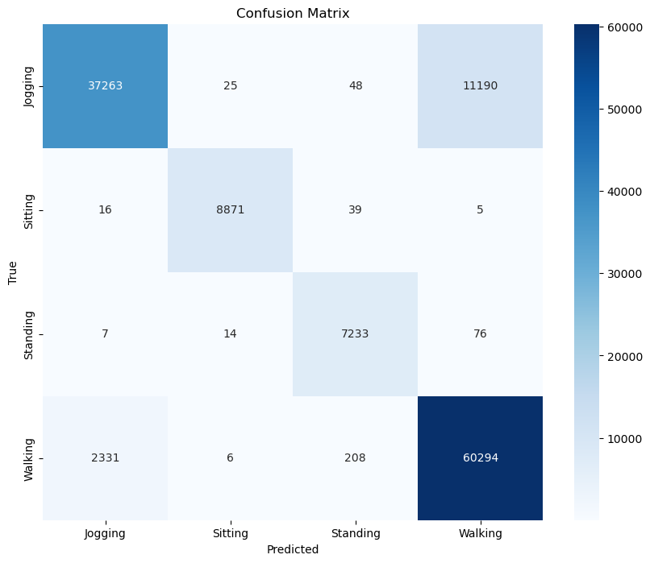
Figure *: Confusion Matrix of CNN
The classification report offers detailed insights into the model's performance, with precision, recall, and F1-score metrics for each activity class. The high precision and recall values across most classes reflect the model's efficacy in accurately identifying activities. The F1-score indicates balanced performance, especially in handling class imbalances.
Table 2: Classification Metrics
Activity | Precision | Recall | F1-Score
Jogging | 0.94 | 0.77 | 0.85
Sitting | 0.99 | 0.99 | 0.99
Standing | 0.96 | 0.99 | 0.97
Walking | 0.84 | 0.96 | 0.90
The CNN demonstrated superior performance in terms of accuracy and robustness, highlighting the advantages of using deep learning techniques for human activity recognition compared to traditional machine learning models, but performed relatively poorly than hybrid model.

The dataset for CNN model is split into training, validation, and test sets with proportions of 70%, 15%, and 15%, respectively. This split is performed using random_split, ensuring a consistent distribution across the different sets. Including a validation set, as seen in CNN final.ipynb, helps in monitoring the model's performance during training and prevents overfitting by tuning hyperparameters.
The dataset for CNN+LSTM model is split into training and test sets using train_test_split from Scikit-learn, with 80% for training and 20% for testing. This split is crucial for evaluating the model's performance on unseen data.

Checking the variability of sensor data (x-axis, y-axis, z-axis) across different activities helps in understanding the nature of each activity and can be crucial for applications such as activity recognition. After checking the standard deviation of the sensor data for each user within each activity, we can find out how much the sensor data varies for each user while performing a specific activity. High values of standard deviation suggest greater variability in the user's movements. For example, for "Jogging," user 1 has a standard deviation of about 10.71 on the x-axis, 9.48 on the y-axis, and 5.65 on the z-axis.

We also checked the mean standard deviation for each activity across all users. This is calculated by averaging the standard deviations of all users for each activity shown as Figure*. We can find out that activities like "Jogging" show high variability, which is expected due to the dynamic nature of the activity. This indicates that users exhibit a wide range of movements. While activities like "Sitting" and "Standing" have low variability, reflecting the stability and minimal movement involved. "Walking" shows moderate variability, suggesting consistent but varied movements.

As displayed in Figure*, the dataset collected 850833 data from 36 users. User 20 has the highest number of samples, followed by User 19 and 3. These users have significantly more samples than others, indicating they are top contributors. Users from ID 29 to 11, have a relatively even distribution of samples, suggesting a balanced contribution from these users. While User 4 has the fewest samples, indicating minimal participation compared to others. The decline in the number of samples from the most active users to the least active ones suggests an potential imbalance.

The median showed in the boxplot gives the central tendency of the data for each activity. Walking, Jogging, and Sitting have medians close to zero, while standing has a slightly lower median, indicating a lower central tendency compared to the other activities. After checking whiskers, we can see that Walking and Jogging have longer whiskers, indicating a wider range of data, while Standing shows several outliers (points outside the whiskers), suggesting some unusual or extreme values in the data.

